Viral Growth
Student
Institution of affiliation

Viral Growth
Introduction
A virus is an infectious agent whose replication occurs inside a living cell in an organism. They can infect all form of organisms from plants to animals to microorganism including Achaea and bacteria. The first virus to be discovered was the mosaic virus that infects tobacco in 1898 by Martinus Berjerrinck. Dmitri Ivanovsky in his 1892 article only talked of a non-bacterial pathogen that infected this plant. To date, over five thousand type of viruses have been described in the biological literature. Virology which is the study of viruses is a subspecialty in the medical field of microbiology (Neri et al., 2013). Outside infected cells, viruses exist as independent cells called virions. They are composed of two to three parts that is the genetic material (RNA or DNA), the capsid (a protein coat) and the viral envelope (surrounding lipid in some types of viruses).
Part 1: The human immunodeficiency virus (HIV).
This is a retrovirus meaning that it uses its reverse transcriptase enzyme to generate DNA from its RNA nuclear genome. The virus thus replicates by reverse engineering its DNA. It belongs to Retroviridae family. This is an important class of viruses as its member cause important diseases in humans like AIDS, neurological diseases, and cancer. HIV is currently classified as a complex retrovirus. Once the virus infects a person, the viral DNA gets incorporated into the host cell chromosomal DNA (a property exploited in gene vector therapy). HIV is currently global epidemic diseases that have killed more than forty million people in the past three decades (Nash, Dalziel & Fitzgerald, 2015). It is still the leading killer in some sub-Saharan African nations. Without treatment, depending on the serotype of HIV, the average survival rate is 9 to 11 years.
HIV growth rate in the body
During the initial primary infection stage, the number of HIV particles in host plasma rises rapidly before reaching a peak and then decline until it attains a set point level that is the quasi-steady state. The virus has a median doubling time of 0.56 days and an interquartile range of between 0.56 to 0.91 days. The virus has a median reproductive ratio (Ro) of 8.0 and an inter-quarter range that lies between 4.9 and 11. A reproductive ratio is the measure of the probability of the virus establishing an infection. It measures the number of healthy cells an HIV infected cell will infect when there is no limitation of target cells. After the peak level, the virus has an average medium decay rate of 0.60 days. This corresponds to a half-life of 1.2 days. Viral load is the terminology commonly used to describe the amount of HIV in one’s blood. The higher the viral load, the higher the amount of HIV in one’s blood and the faster ones CD4 count will fall. This is an important predictor of one getting ill due to the virus. The median peak viral load for HIV is 5.8 Log (10) HIV RNA copies per milliliter (Nash, Dalziel & Fitzgerald, 2015). This is achieved after 14 days of viral replication. The growth of rate depends on the death of infected cells, and the availability of target cells at a constant rate due to the viral cytopathic effects. This represents the cell-limited model of HIV replication rate.
The growth rate of the HIV is represented by the following exponential growth function (Scott, 2015):
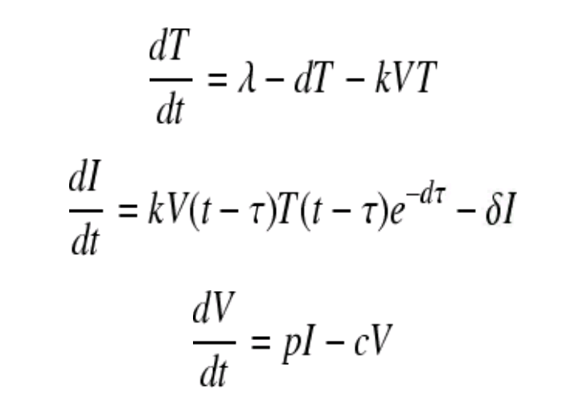

The following table represents the number of virus particles (virions) that can grow inside one’s body.
Day | Number of virus particles (Viral load) | Number of CD4 cells in the body
0 | 1 (undetectable) | 1200
1 | 50 | 1700
2 | 100 | 1420
3 | 250 | 1300
4 | 800 | 1240
5 | 1950 | 1009
6 | 4980 | 911
7 | 10000 | 850
8 | 20000 | 800
9 | 37000 | 750
10 | 32000 | 700
11 | 30000 | 600
12 | 2000 | 500
13 | 15000 | 550
14 | 14500 | 580
15 | 14950 | 600

The long-term growth trajectory of the virus is as follows
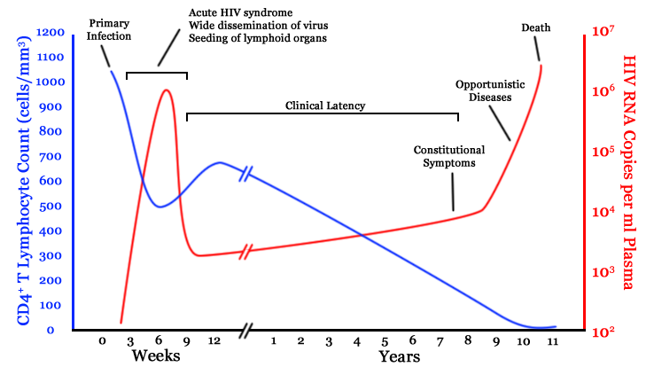

Part 2
The human body is equipped with the defensive mechanism that is meant to protect against the acquisition of infections. There are two defense mechanisms in the body. The innate and the adaptive immune system. In the initial phase of HIV infection, the body innate immune system attempts to fight off the infection but is rapidly overwhelmed by the body immune system since it is not adapted to fighting viruses (Scott, 2015). The adaptive system takes time to come into play, and by that time the infection usually has spread all over the body. The system starts to take its course usually one to two weeks after infection. At this point, the body begins to produce immune cells that are capable of fighting off the infection. As the body starts to fight off the infection, the patient may experience fever, a flue like illness, myalgia, malaise and pain in the joints (arthralgia). This is the acute seroconversion stage at which anti-viral immune cell begin to appear in the blood (Nash, Dalziel & Fitzgerald, 2015).
In the absence of the body’s immune system, the HIV would grow exponentially before reaching a plateau level and remain at that level indefinitely, a point at which the number of CD4 cell produced is equivalent to the number of CD4 cell death due to cytopathic effects (Nash, Dalziel & Fitzgerald, 2015). As the adaptive body immunity gets activated, intense inflammation occurs in the body as it attempts to fight off the infection. This stalls the rise of HIV level in the body. The virus level begins to fall rapidly as the antiviral immune cells in the body fight it off. This will continue until the virus level falls back to the undetectable level. However, this will be strongly influenced by the pre-infection general health of a person (Scott, 2015). If the person had a comorbidity like diabetes mellitus which serves to suppress the body’s immune system, the viral load would not fall to the undetectable level. Rather, a new steady state will be achieved at a relatively higher viral blood level.

Many factors influence how the body responds to HIV infection. This is strongly influenced by the genetic and environmental factors. The victim’s human allelic variants strongly influence one's susceptibility to this infection hence the trajectory the infection ultimately follows. The cellular proteins that participate in HIV replication has a huge role in the speed of HIV replication. Other factors to be considered in determining the rate of growth of HIV included viral factors that determine how the virus can escape the body immunity or the replicative virus properties and the cellular factor in the body that corporate with the virus as it replicates in the human body (Scott, 2015).
The represent the number of HIV virus in the body

The change in viral level in the body as adaptive immunity comes into play:

Part 3
The exponential growth model as illustrated in the replication of HIV in the human cell can be applied in the explanation of spread of viruses from one person to another. This is however influenced by a variety of factors. The first factor to consider is the type of the virus. This influence the mode of spread. The transmission of viruses is strongly influenced by factors like viral infectivity, the host defense mechanism, the host behavior and the environmental determinants. For respiratory viruses, environmental conditions that influence their spread included humidity and temperature, precipitation, ventilation, and airflow. For HIV virus, the following are the major factors that have to influence its spread world over (Nash, Dalziel & Fitzgerald, 2015). They include poverty, illiteracy, and ignorance, the stigma associated with the condition, socio-cultural factors, ignorance, and promiscuity. Civil wars and tribal factors, movement of people and immigration, poor medical services, substance, and alcohol use.
The spread of a virus inside a human host is much faster than that between people. This is because, in the human body, there is unlimited number of particles the virus can attack before the body develops adaptive immunity. The spread between human hosts is slow because the virus must undergo an incubation period inside a human host before the person become infections. Once a person is identified as infection, his transmission of the infection to others can be limited by public health measures (Nash, Dalziel & Fitzgerald, 2015). The growth trajectory of these infections both in the human host and between hosts adopt a similar shape when plotted on a graph.
Part 4: Online videos
Videos when posted online spread like viruses. Their spread is exponential, receiving a lot of view in the earlier stages but which gradually decrease over time until it loses favor in the market. Unpopular video receives very few like when initially posted. The likes despite being less, rise to a given level and plateau at that level.
The following exponential growth function models the growth of views on online videos that have been uploaded to social media sites like Facebook. The growth rate of these views as time (t) goes by at discrete intervals (for instance daily) is as follows:
xt = x0 (1+ r)t
Where x0 is the actual number of view of the videos x at time 0.

The video received 2000 vies on the first day. Its decay factor was taken as -5.

Part 5
The following represents the exponential growth curve of a popular video with a growth factor of 20.

Data
Day | Unpopular of views | Views on the Popular video
0 | 2000 | 2000
1 | 1900 | 2400
2 | 1805 | 2880
3 | 1714 | 3456
4 | 1629 | 4147
5 | 1547 | 4976
6 | 1470 | 5971
7 | 1396 | 7166
8 | 1326 | 8599
9 | 1260 | 10319
10 | 1197 | 12383
11 | 1137 | 14860
12 | 1080 | 17832
13 | 1026 | 21398
14 | 975 | 25678
15 | 926 | 30814
16 | 880 | 36976
17 | 836 | 44372
18 | 794 | 53246
19 | 754 | 63895
20 | 716 | 76675
21 | 681 | 92010
22 | 647 | 110412
23 | 614 | 132494
24 | 583 | 158993
25 | 554 | 190792
26 | 527 | 228950
27 | 500 | 274741
28 | 475 | 329689
29 | 451 | 395627
30 | 429 | 474752

Differences in graphs.
The popular video receives an increasing number of views over the one-month duration. The growth factor was positive at a growth rate of 20. The graph thus adopted an upward trajectory. The unpopular video received a decreasing number of views over the one-month duration with a dray rate of -5.
Part 6
The factors that were not taken into account while drawing the graph and which could impact on the views of the video include the social media site used, the target audience of the video, the region the video was released, the internet penetration rate in the target population, and possible government censorship programs. The strength of the message in the video and its appeal to emotions play a huge role in the number of views a video receives (Whiting & William, 2013).
I would take into account the target audience of the video. Videos that tend to be appealing to the younger generation tend to receive more views. This is because this is the age group that spends most of their time online unlike old mature people. I would watch the videos to gauge the strengths of their message and likely appeal to emotions. Taking these factors into account will be useful in gauging whether the right growth factor or decay rate was used in coming up with the graphs (Fan & Gordon, 2014).). Any alteration in these figures is likely to alter the eventual appearance of the graphs.

References
Fan, W., & Gordon, M. D. (2014). The power of social media analytics. Communications of the ACM, 57(6), 74-81.
Murray, P. R., Rosenthal, K. S., & Pfaller, M. A. (2015). Medical microbiology. Elsevier Health Sciences.
Nash, A. A., Dalziel, R. G., & Fitzgerald, J. R. (2015). Mims' pathogenesis of infectious disease. Academic Press.
Neri, D., Somarriba, G. A., Schaefer, N. N., Chaparro, A. I., Scott, G. B., Mitnik, G. L., ... & Miller, T. L. (2013). Growth and body composition of uninfected children exposed to human immunodeficiency virus: comparison with a contemporary cohort and United States National Standards. The Journal of pediatrics, 163(1), 249-254
Scott, D. M. (2015). The new rules of marketing and PR: How to use social media, online video, mobile applications, blogs, news releases, and viral marketing to reach buyers directly. John Wiley & Sons.
Whiting, A., & Williams, D. (2013). Why people use social media: a uses and gratifications approach. Qualitative Market Research: An International Journal, 16(4), 362-369.

